Automated Static Testing

What is Automated Static Testing
# Source: AI Source: Provided by: [Data Path: Persons Table -> ID Column: 1, Name_En Column: Motasem Essam] -> From: [Chatgpt (GPT‑5 Mini)] on [8/23/2025]
Automated Static Testing is a type of software testing where tools automatically examine artifacts (code, documents, models) without executing the program to find defects, inconsistencies, or violations of standards.

Key Points
# Source: AI Source: Provided by: [Data Path: Persons Table -> ID Column: 1, Name_En Column: Motasem Essam] -> From: [Chatgpt (GPT‑5 Mini)] on [8/23/2025]
- Static → The software is not run; the analysis is done on the code or documents as they are.
- Automated → The inspection is done by specialized software tools instead of humans manually reviewing.
- Goal → Detect defects early, reduce human review effort, and enforce coding/documentation standards.

Examples
# Source: AI Source: Provided by: [Data Path: Persons Table -> ID Column: 1, Name_En Column: Motasem Essam] -> From: [Chatgpt (GPT‑5 Mini)] on [8/23/2025]
- Static Code Analysis Tools
  - Detect syntax errors, unused variables, dead code, security vulnerabilities, or performance issues.
  - Tools: SonarQube, ESLint (JavaScript), Pylint (Python), Checkstyle (Java).
- Automated Document Checks
  - Verify completeness or formatting of requirements documents, test cases, or architecture diagrams.
  - Example: Requirements tools that auto-check for ambiguous words like “quickly” or “user-friendly”.
- Security Scanners
  - Look for vulnerabilities like SQL injection risks, insecure dependencies, or missing encryption.
  - Tools: OWASP Dependency-Check, Bandit (Python security).

Benefits
# Source: AI Source: Provided by: [Data Path: Persons Table -> ID Column: 1, Name_En Column: Motasem Essam] -> From: [Chatgpt (GPT‑5 Mini)] on [8/23/2025]
- Faster feedback than manual reviews.
- Detects issues that humans may overlook.
- Can run continuously in a CI/CD pipeline.
- Reduces cost by catching problems early.

Difference from Manual Static Testing
# Source: AI Source: Provided by: [Data Path: Persons Table -> ID Column: 1, Name_En Column: Motasem Essam] -> From: [Chatgpt (GPT‑5 Mini)] on [8/23/2025]
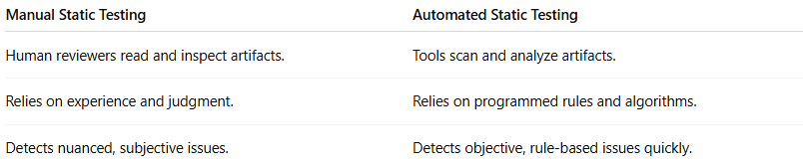
Manual Static Testing | Automated Static Testing
Human reviewers read and inspect artifacts. | Tools scan and analyze artifacts.
Relies on experience and judgment. | Relies on programmed rules and algorithms.
Detects nuanced, subjective issues. | Detects objective, rule-based issues quickly.

